Bloomberg volunteer team

Videolink Information Pack

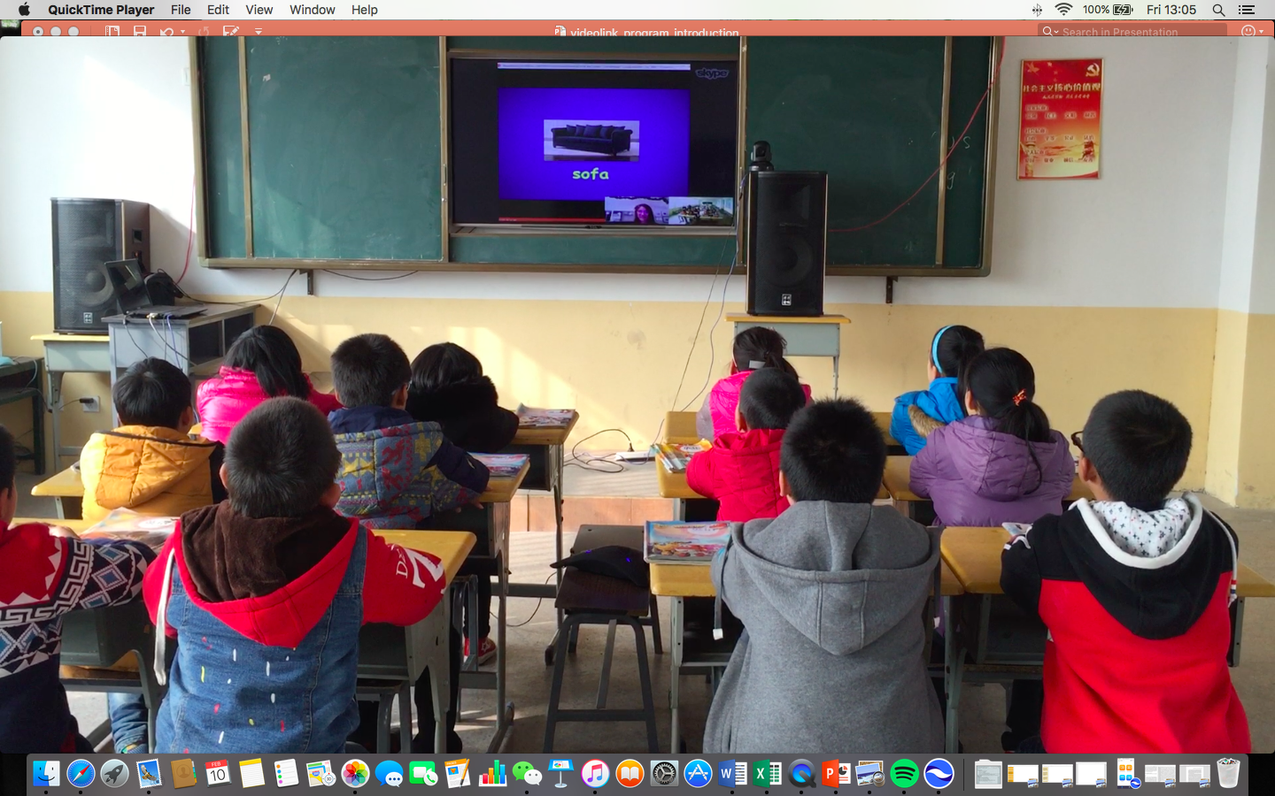

Fall 2017

Contents:

1. Your class

2. Classroom Teacher

3. Zhumu account

4. Invitation-to-training protocol

5. Contacts

1. Your class

**Seating plan**

|  |  |  |  |
| --- | --- | --- | --- |
| **Blackboard** | | | |
| **Tuesday 7:20-8:00 Grade 4** | | | |
| jia(1)cheng(3) | jing(1)jing | ming(3)yue(4) | huan(4)huan(4) |
| lin(3)yu(3) | xiang(4)yang(3) | xiao(3)qing(4) | zhao(1)yang(3) |
| zhao(4)yue(4) | ni(2)na(4) | jiao(2)jiao(2) | ao(4)yun(4) |
| meng(4)bo(2) | yu(3)qing(2) | zi(3)yan(1) | jia(1)hui(4) |
|  |  |  |  |
| **Blackboard** | | | |
| **Tuesday 13:30-14:10 Grade 3** | | | |
| xiang(4)kai(3) | cheng(2)zhen(1) | shu(1)yao(2) | chen(1)chen(1) |
| zhang(2)shuo(2) | xu(2)qing(2) | yue(4)kai(3) | shi(1)yue(4) |
| chen(2)hao(4) | rui(4)xin(1) | jia(1)shun(4) | xu(4)kun(1) |
| zi(1)xuan(1) | hao(4)xian(2) | yi(1)han(2) | meng(4)tian(2) |
|  |  |  |  |
| **Blackboard** | | | |
| **Wednesday 18:00-19:00 Grade3** | | | |
| kai(2)jia(1) | yu(4)zi(1) | xing(1)chen(2) | zi(1)jia(2) |
| xue(3)er | yi(1)yi(1) | shu(1)wen(2) | ke(1)ke(2) |
| jiao(2)hui(4) | ni(2)ni(2) | su(1)xin(1) | jia(1)xin(1) |
| jin(1)ku(4) | shan(1)ge(2) | zi(1)han(2) boy | lan(2)lan(2) |
|  |  |  |  |
| **Blackboard** | | | |
| **Thursday 07:20-08:00 Grade 4** | | | |
| xin(1)xin(1) | rui(4)ying(2) | jia(2)hui(4) | meng(4)xin(1) |
| guo(1)zi(1)hao(2) | wen(1)zhuo(2) | ao(4)di | lu(4)ying(1) |
| jia(1)heng(2) | ting(2)ting(2) | sun(3)shuo(4) | sun(3)yan(1) |
| miao(3)yu(3) | jing(3)li(4) | yan(4)yang(2) | bo(1)qing(2) |
|  |  |  |  |
| **Blackboard** | | | |
| **Thursday 16:00-17:00 Grade 3** | | | |
| jia(1)yin(1) | jin(1)yuan(2) | wen(2)jing(4) | si(1)wen(2) |
| can(4)can(4) | guo(1)xu(4) | si(1)miao(3) | ya(4)wen(2) |
| yi(4)chen(2) | zhang(1)hui(2) | xu(4)bo(1) | tian(2)yun(4) |
| rui(4)xiang(2) | sun(3)miao(3) | sai(4)bo(1) | qiu(1)yang(2) |
|  |  |  |  |
| **Blackboard** | | | |
| **Wednesday 18:00-19:00 Grade 4** | | | |
| jia(1)hao(2) | ao(4)yang(2) | zu(1)rui(4) | wan(3)qing(2) |
| yuan(1)yuan(1) | xin(1)hao(4) | zi(1)han(2) | zi(4)ran(2) |
| yang(2)yang(2) | meng(4)xiang(3) | yin(2)hang(2) | sun(3)rui(3) |
| sun(3)heng(2) | zi(1)kang(3) | han(3)zhen(1) | xiao(1)xue(3) |

2. Classroom Teacher

**Tuesday:**

**7:20-8:00 Ms. Liu Yijun 刘奕君 (WeChat id: liuyijun829)**

**13:30-14:10 Ms. Yan Can 闫灿 (WeChat id: yancan2553)**

**Wednesday:**

**18:00-19:00 Ms. Liu Yijun 刘奕君 (WeChat id: liuyijun829)**

**Thursday:**

**7:20-8:00 Ms. Sun Yanying 孙艳英 (WeChat id: wxid_irh7nsm74wen22)**

**16:00-17:00 Ms. Ye Jianting 叶建婷 (WeChat id: yjt12030605)**

3. Zhumu account

**Login**

yuanbo.RT1@steppingstoneschina.net

password: yuanbort1

yuanbo.RT2@steppingstoneschina.net

password: yuanbort2

4. Invitation-to-training protocol

**Step 1.** Log in to Zhumu and click on ‘Start with video.’

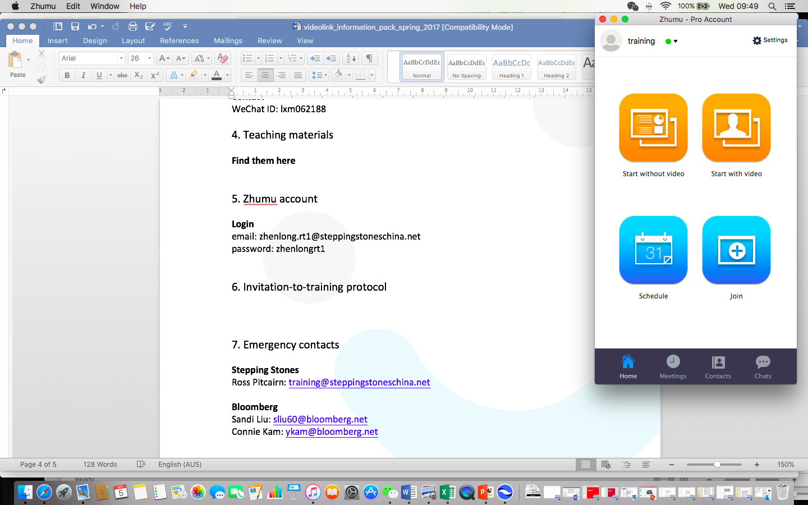

**Step 2.** You will see the meeting id at the top of the screen.

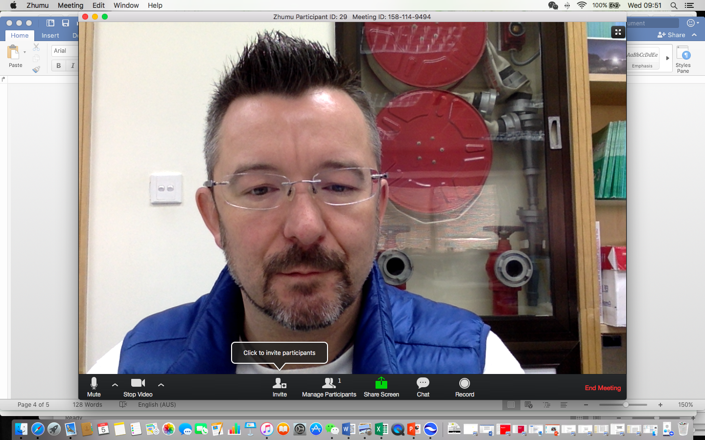

**Step 3.** Send it to your CT via email or the We-chat group at least 10 MINUTES before class is due to begin.

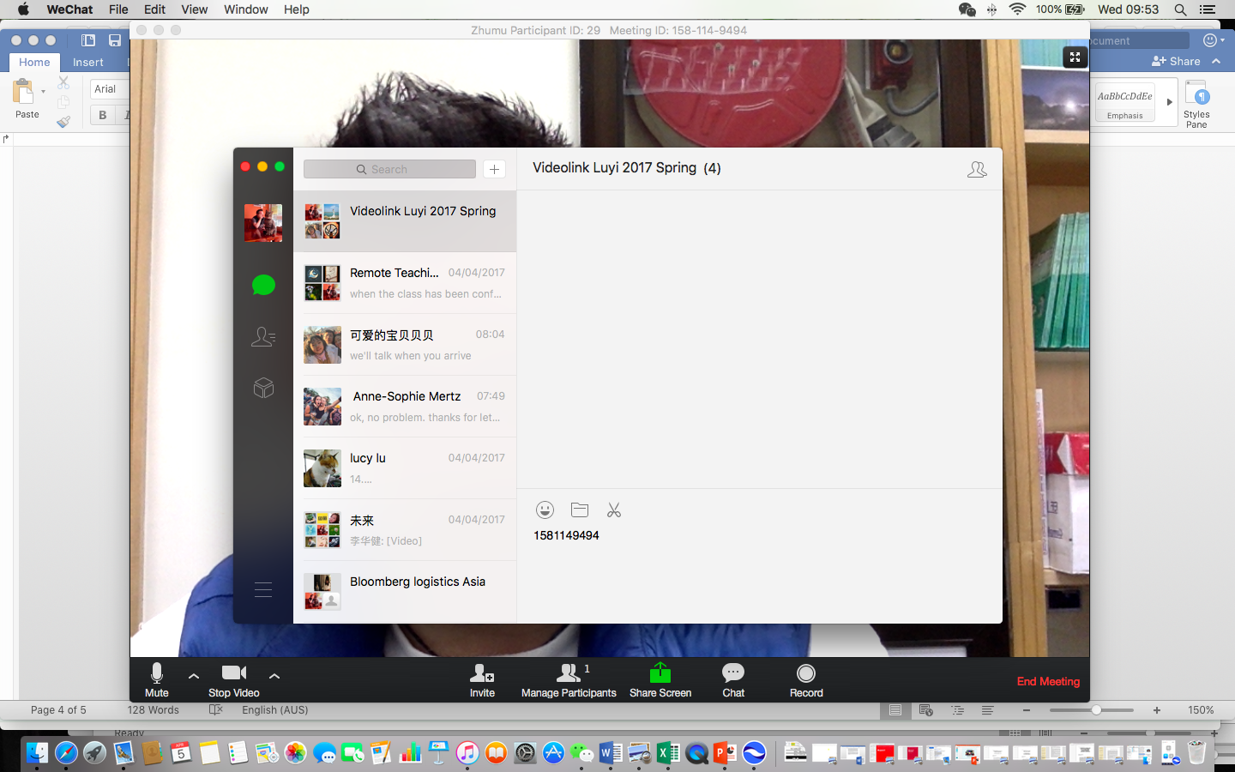

**Step 4.** Wait for your class to join the meeting.

5. Emergency contacts

**Stepping Stones**

Sherry Jia: [program@steppingstoneschina.net](mailto:program@steppingstoneschina.net)

Ross Pitcairn: [training@steppingstoneschina.net](mailto:training@steppingstoneschina.net)